Board of Governors
“Harvest Between the Rivers”
October 20 - 21, 2026 | Franklin, VA
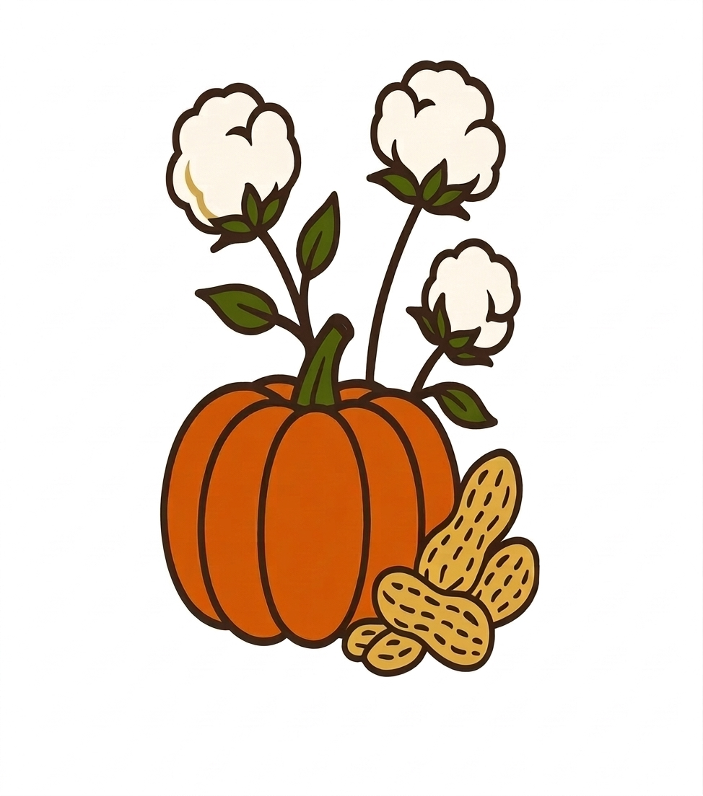
Schedule of Events:
Tuesday , October 20th
11:00am – 3:00pm
- GCV Board Meeting and Registration: SERVE Restaurant and Taphouse, Franklin
- Other members registration: Hilton hotel, Suffolk
3:00pm - Members drive to Suffolk for hotel check-in.
4:30pm – Buses leave hotel for Blackwater Park
5:15pm – 6:00pm – Dedication Ceremony at Blackwater Park
6:15pm – 7:00pm – Meet and Greet at The Hubs Vine
7:00pm – 9:00pm – Board of Governors Fall Banquet at the Hubs Vine
9:00pm – Buses return to Hilton in Suffolk
Wednesday , October 21st
8:00am - 9:30am
Horticulture Set-up: Workforce Development Center, Camp Community College
8:30am – 9:30am – Breakfast
9:30am – 12:00pm – Meeting
12:00pm – Drive to The Village at Woods Edge (Carpool)
12:15pm – 1:30pm – LUNCH at The Back Porch & Grille, The Village at Woods Edge
1:30pm-1:45pm – Return to Workforce Development Center
2:00pm – 4:00pm – Afternoon Meeting
4:00pm – Meeting adjourned. Remove horticulture.
4:15pm – 7:30pm – “Celebration Cookout” at Fred’s Restaurant
All BOG attendees are invited.

